Agent Recruiting Script
Introduction
Hi, this is (YOUR NAME) with Sellstate Realty? Well I was just calling on behalf of my broker (INSERT NAME), who wanted you to stop by our office so that he could show you how Sellstate is making agents more productive. So what day would work better for you (TOMORROW) or (NEXT MONDAY)?
Are you open minded when it comes to your business? (Awesome)
Deliver 3 Benefits
We’re expanding because Sellstate is offering one of the highest splits in the industry, so agents are making more money off every deal. Is a high split something you look for in a real estate brokerage? (Well great) When would you be able to stop by the office so I can show you how we have some agents on splits over 100%, (DAY) or (DAY)?
Another reason agents are benefiting and producing more deals annually with Sellstate is because of the technology package that Sellstate offers all its agents at no charge. It includes a personal website, CRM, lead generation, enhanced listings on homes.com and Zillow, so it would be better for you to stop by the office at (TIME) or (TIME) so we can show you more about our free technology package?
One thing that the real estate industry has truly lacked over the years is providing an exit strategy for agents, like a pension program. Would you agree? At Sellstate we have a company funded pension program that all of our agents receive, so that when they are ready to retire they can! I know this is something that you want to at least hear more about, so is (DATE) or (DATE) better for you?
Open Minded
Well previously you told me that you were open minded about your business, and when I hear that someone is open minded, I love it because I know that they always willing to at least hear out an opportunity to see if it can help better their current business. So that’s all I want is for you to be open minded about your business and stop by our office so we can share with you the benefits of Sellstate Realty for agents.
So would (TIME) or (TIME) work better?
Conclusion
I want to thank you for your time today, but before I let you go do you know of any agents that are looking to make a move or interviewing other offices at this time? (Well thanks) Well it was great speaking to you today & I wish you the best of luck with your business! I will follow up with you in a month or two just to see how everything is going with you but until then have a great one.

Objection Handling
Currently Happy
I completely understand that you are happy where you are at but being happy with how everything is going does not mean that there is not a better option out there. So that’s all I am asking, is to stop by our office and let us share with you how Sellstate Realty is helping agents make more money & produce more deals. I mean we are going to share with you things that you can even apply to your current business the moment you leave the office.
So what day worked better (DAY) or (DAY) ?
Destination Broker
I am sorry, you must have misunderstood me. I am not calling to recruit you. Are you familiar with what a destination broker is? Well as a destination broker I just want to inform you how Sellstate is taking agents to the next level and increasing their production. As a destination broker, I know you don’t plan to move now, but at least you'll know about a viable option should a change come about. Because one thing that is constant in this industry is change. I still want you to stop by the office and see what we're doing to benefit agents.
So are you free to stop by on (DAY) or (DAY)?
Opportunity
Successful entrepreneurs are always looking for a great opportunity. It doesn’t mean that they take all these opportunities, but they at least look into them and hear them out. So that’s all I want is for you to at least take the time to look at this opportunity, and then after you can make an educated decision whether or not if this opportunity you are looking to pursue.
So what date worked better (DATE) or (DATE) ?

Cancelled/No Show Script
Hey, this is ________ with Sellstate Realty. I was just following up because you weren’t able to make our appointment. I completely understand that you’re busy, but our manager did set aside time to meet with you. I want to schedule another appointment with you and our manager, but before I reschedule this appointment, I have to know that you will be able to make it to this next one because I can’t have our manager put time aside again and you not show up. I know this meeting will really benefit you because like I previously said we’re increasing agent’s production, as well as offering agents a free technology package & company funded pension plan. So does _______ or _______ work better for you? Well now that we’re setting this time aside, you have to promise me that you’re going to make it to this appointment because our manager is going to set time aside to meet with you one on one, fair enough? Well thank you so much for your time and he is really looking forward to meeting with you on _______ at ______.

Agent Recruiting Script Outline
Introduction
Introduce yourself & end your intro with a presumptive close
Deliver Open Minded Questions
Ask in your intro if they are open minded about their business
Deliver 3 Benefits (AAD, High Commission, Technology Package, Training)
At the end of every benefit deliver a presumptive close
Never deliver more than 3 benefits, move on if they haven’t been closed by the 3rd
Close Open Minded Questions
Follow up with your previous question, with the open minded close
Conclusion & Ask for Referrals
In closing thank them for their time and ask for agent referrals

Handling Objections
Destination Broker
Only deliver if they say they do not want to move OR ask if you are recruiting
Currently Happy
Only deliver if they say that they are happy where they are at OR with what they’re doing
Opportunity
Deliver before your conclusion if you forgot to ask the open minded question earlier in the conversation.

Script Notes
*Speak slow / fully pronounce words & use your hands & movement for inflexion in voice
*YOU CAN’T HIRE SOMEONE ON THE PHONE, YOUR JOB IS TO CLOSE FOR THE APPOINTMENT

CRM Notes
If any of these categories describe an agent, make sure to add that category to the contact.
Assistant Commercial Agent Property Management Agent
Broker Owner Office Manager
Retired Relocated Part Time Agent
Not Licensed Sellstate Agent Spanish Speaking Agent
Mortgage Broker Deceased Appt. Scheduled
No Show Appt. Cancelled Appt. Showed Up To Appt.

After making first contact (speaking to, NOT leaving message or no answer)
*Update Categories to “Agent”
*Change last contact date to today
*Add to drip campaign
“No Appointment Booked (Follow Up)” or “Appointment Booked (Follow Up)”
*Insert the date & time and add any notes about the conversation
*If they say to follow up with them then create a task and title it as
“Follow Up To Schedule Appointment” & set it up to the day requested to call back
After leaving a message or they do not answer & you don’t leave a message
*Update Categories to “Agent”
*DO NOT Change the last contact date
*DO NOT Add to drip campaign yet
*Insert the date / time and put “LM” if you left a message or “NA” for no answer

Follow up calls that did not answer
*The only things you do if they don’t answer is: insert the date / time to the notes and
put “LM” if you left a message or “NA” for no answer. The last step is to go to the task
menu & edit the task to change the date of the task to a future date to try calling again.

Follow up call where contact was made
*Change last contact date to today
*Insert the date & time and add any notes about the conversation
*If they say to follow up with them then create a task and title it as
“Follow Up To Schedule Appointment” & set it up to the day requested to call back

Appointment Booked
*Add to the Appointment Booked (Follow Up) campaign
*Edit emails
*Add the appointment date/time, office address, make sure salutation has name
*Emails & tasks set to the right date (1 day booked, 1 day before, text day of)
*Send emails to office & manager / add the appt to the Google Calendar

Appointment Booked
*Add to the Appointment Booked (Follow Up) campaign
*Edit the emails on the campaign
*Add there name after where it says Good Morning or Good Afternoon
*Include the appointment date/time as well as the office address
*Make sure that the emails & tasks are set to the correct days
1) Email goes out the day that you schedule the appointment
2) Email goes out the day before their appointment
3) Text them the morning of their appointment as a reminder
*Send an email to the office manager, admin & sellstateleader (which includes)
*First & Last Name
*Company – City
*Cell Phone Number
*Email Address
*Website, Facebook or LinkedIn (All that are available)
*Appointment Date & Time
*Recruiter Name Who Scheduled The Appointment
*Copy the content from your email, and paste it in the Google calendar until the notes for the appt. time

Sample Email

Good Afternoon Taylor,
Thank you for taking the time to speak with earlier today. We look forward to spending some time with you at the meeting & going over the exciting programs, tools and benefits of Sellstate. Our broker, Lynda Moritz, has set aside time so that he can meet with you & go into detail about everything that Sellstate does for their agents.
To learn more about the amazing lead generation that reaches over 100,000,000+ unique monthly visitors with custom enhanced listings and the comprehensive and easy to use technology tools provided by the Sellstate Power Suite, please take a couple of minutes to look at the video link below.
http://sellstaterealty.com/join-autoplay
We look forward to your visit to @ 3:00 pm on Monday, June 6th
Our office address is 3321 Del Prado Blvd S. Cape Coral, FL 33904
Sincerely,
Sellstate Select
Business Development
sellstateleader@gmail.com

Uploading Contact’s
*These are the things that must be typed in for every contact put in the CRM
*Name
*Company – City
*Cell Number
*Email
*Website, Facebook, LinkedIn (Links if applicable)
EXAMPLE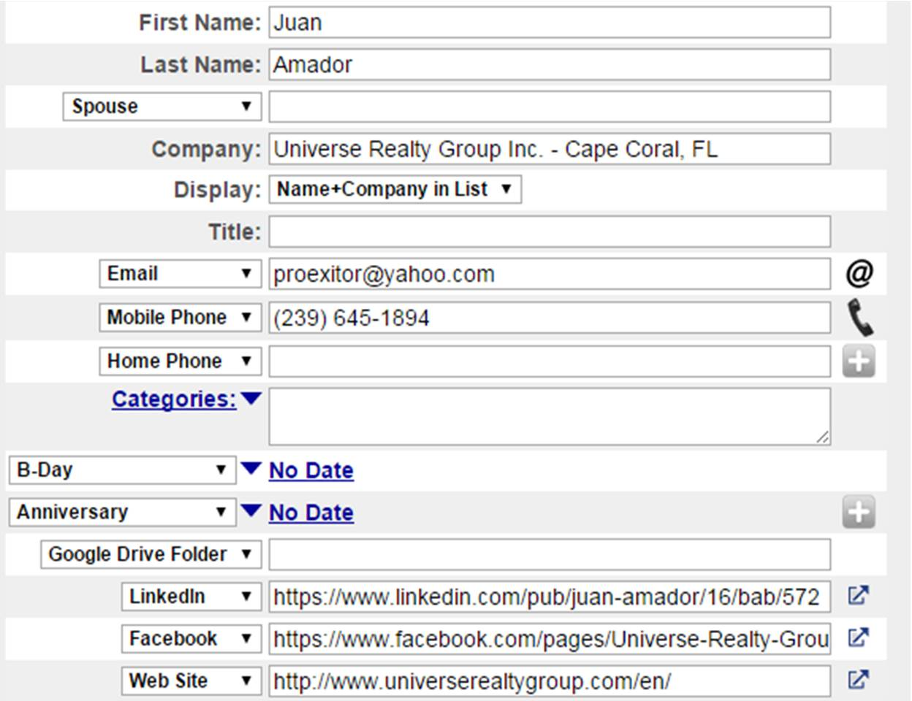

*NOTE: The first 200 contacts uploaded should have produced a volume less than $1,000,000 over the last year. The reason we upload these first is because these appointments are easier to schedule and you won’t burn all the good agents while you are getting started with scripts and getting comfortable with recruiting and the interviews.

Post Appointment Survey
1. What benefits did you like most about Sellstate and why?
2. Were there any concerns with what you heard about Sellstate?
3. How confident are you that you can close more deals with Sellstate?
4. Do you think the interviewer/manager did a good job presenting the Sellstate value proposition and are you clear on the benefits & what is offered at Sellstate?
5. On a scale from 1-10 what is the likely hood of you joining Sellstate?

*The day after the appointment the admin or receptionist must follow up with the agent who came to the interview and go over the “Post Appointment Survey”. Keep in mind that we do not want whoever handled the interview to do the post appointment survey, because agents will more likely be honest if they’re not speaking to the person that they had the meeting with.
*The post appointment survey was created to be a tool for recruiting so use it to your advantage. When following up with an agent you now know some benefits & concerns with what they thought about the interview & Sellstate.
*After a post appointment survey is completed & filled out please scan and email a copy of it to sellstateleader@gmail.com so we can stay up to date what agents are thinking about Sellstate

Call Tracker
Follow Up Date:
Answered:
Left Message / No Answer:
Returned Call:
New Contacts Date:
Answered:
Left Message / No Answer:
Returned Call:

Creating a task
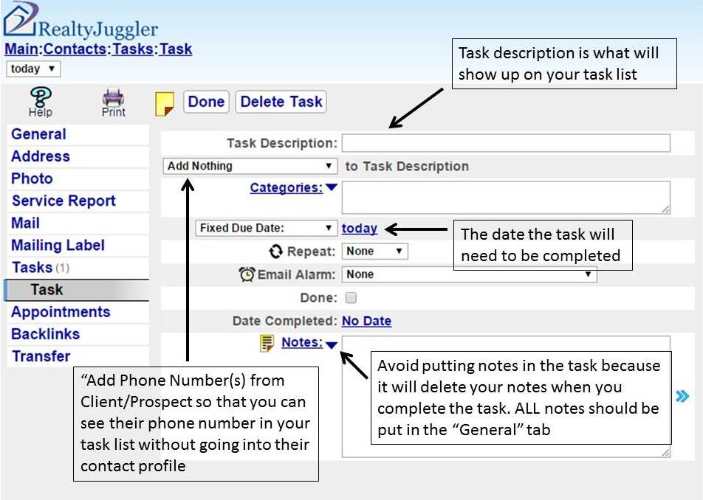

Adding a contact to a campaign

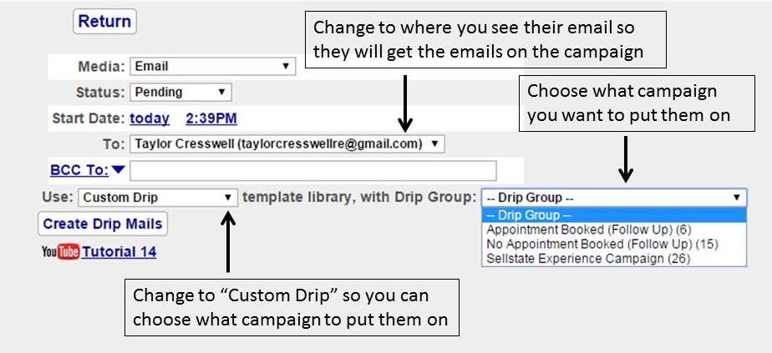

Appointment Spreadsheet

*Once an appointment is scheduled you must add them to the “Appointments Set Monthly” spreadsheet, and include all necessary information. To keep track of which ones showed and which ones didn’t we color the text.
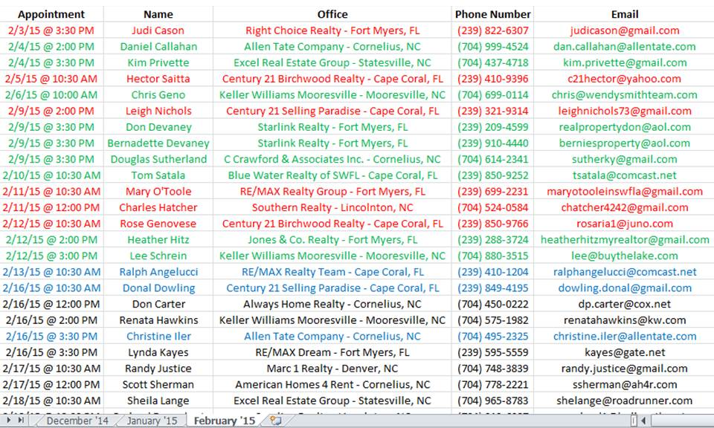

Change the text color for the row to RED if they do not show up to their appointment
Change the text color for the row to GREEN if they do show up to their appointment
Change the text color for the row to BLUE if it is an appointment that is rescheduled

